Zachary Waters

Ellen Zegura

4/9/2019

CS 3251

Homework 3:

P11: Removing the self-transition action from the “wait for 1 from below” state, would result in deadlock. This is because the receiver does not send an “ACK” packet back to the sender upon receiving a non-corrupted packet. This means the both the sender and the receiver are waiting on a response from each other. Removing the self-transition action from the “wait for 0 from below” state, would similarly result in deadlock. This can happen because the sender could send its packet to the receiver, have it corrupted along the way, and the receiver does not respond by sending a “NAK” back to the sender. This similarly causes both the sender and the receiver to both be waiting from a packet from the other.

P14: In a situation where the sender sends data infrequently, a “NAK” only protocol would not be preferable to one that includes “ACK”’s. This is because the receiver misses a packet, it must wait till it receives the following packet before it recognizes that there was an error occurred. Because the sender is sending data infrequently in this situation, it could take a long time for the receiver to recognize such problems and try to recover the data. In the other situation its more beneficial to have a “NAK” only protocol because with a connection with few losses, not having to respond with an “ACK” after every received packet can save time and resources.

P16: This system would result in more channel utilization because this application would allow the sender to pipeline data through the channel. Some potential problems could be that the receiver sends an “ACK” for a packet that it has not received yet, which means the sender assumes the packet arrived successfully and will not retransmit it.

P19:

FSM for the sender: Initialize by sending the packets to B and C with a sequence number 0. Send the packet to B and C and start a timer. Wait till you receive ACKs back from B and/or C. if you do not receive ACK packets back before the timer expires, resend the packet to B and/or C.

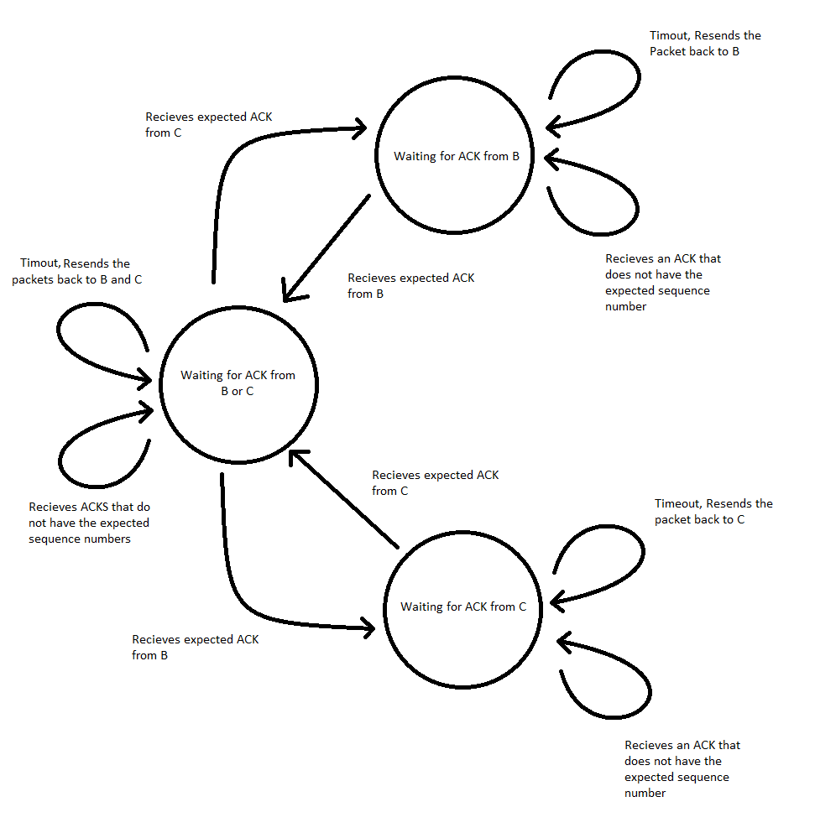

FSM for the receiver C and B. Wait to receive a packet, check if its uncorrupted, send ACK to the sender and start timer, if the timer expires before receiving another packet, then resend the ACK.

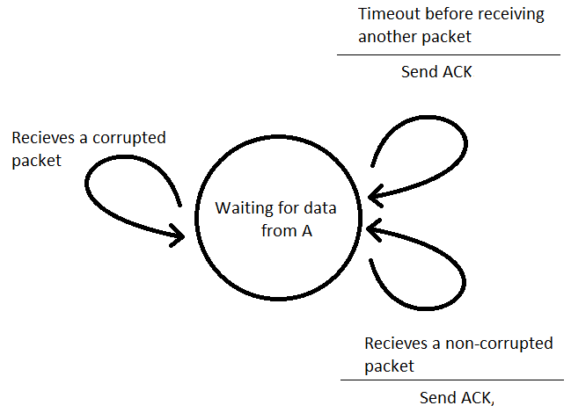

P20:

FSM for the sender A and B: Sends its message to C with a sequence number and starts a timer, waits till its gets an ack back with a matching sequence number, resending the message till it does, upon getting a matching ACK back it starts sending its next message with sequence number X+1.

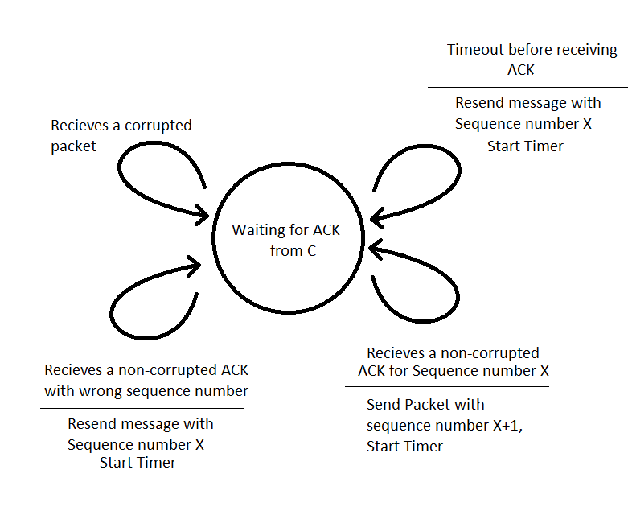

FSM for the receiver C: the receiver works by waiting for a packet with a sequence number X from A, then upon receiving said packet, it transmits back an ack and waits till A starts transmitting its next packet with sequence number X+1, before it switches to waiting for a packet with sequence number Y from B, where the cycle repeats. This ensures that senders have received their acks and advanced to their next packets before the receiver switches to listening to the next sender.

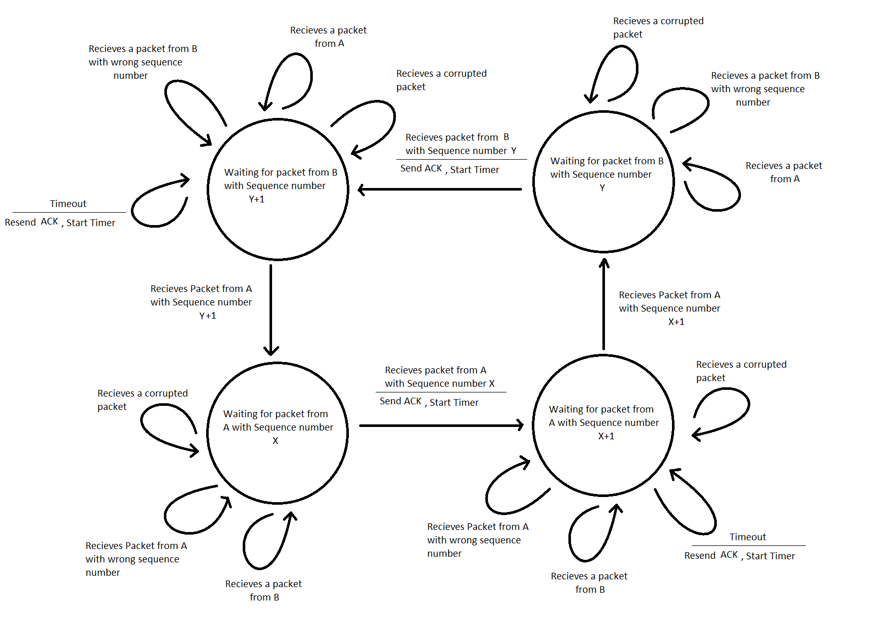

P24:

a) True, if the time it takes to receive “ACK”’s from the first window is longer than the timeout from the sender, duplicate packets would be sent to the receiver. These duplicate packets would result in a second set of “ACK”’s being sent back to the sender. After the first set of “ACK”’s arrives, the sender’s window would shift, causing the second set of “ACK”’s to fall outside the window.

b) True, if the time it takes for the receive an “ACK” is longer than the timeout from the sender, duplicate packets would be sent to the receiver, resulting in duplicate “ACK”’s being transmitted back, this will lead to the sender’s window shifting after getting the first “ACK” and then having the second “ACK” fall outside the window’s range.

c) True, with a window size of 1, you would only need a 1-bit sequence number, either a 0 or a 1, as a cumulative “ACK” is the same as a normal “ACK” in this situation. Thus, SR and alternating-bit protocol are the same.

d) True, with a window size of 1, it is impossible to have out of order packets, and a cumulative “ACK” is the same as a normal “ACK” in this situation. Thus, GBN and alternating-bit protocol are the same.

P27:

a) The sequence number is the first segment of sequence number plus the destination por number, so 127 + 80 = 207, the source port number is 302, and the destination port number is 80.

b) The acknowledgement number is 207, source port number is 80, and the destination port number is 302.

c) The acknowledgement number is 127, indicating that it is still waiting for bytes 127 and onwards.

d)

